THE HOMES, INC December 2011

NEWSLETTER

THE HOMES, INC ∙660 MANORCREST, KANSAS CITY, KS 66101 ∙913-321-2471∙www.thehomesinc.com

Inside This Issue

Maintenance Fee Increase 2-5

Neighborhood Watch 6

Board Meeting Minutes 8-11

Events 13

Remembrance 14

Hints about living in The Homes 15

Helpful pet/animal information 16

Public Service Announcements 17-18

Units for Sale 19

Q.H.F.C.U 20

Calendar 21

Fun & Trivia 22

**MAINTENANCE FEE INCREASE (See page 2)**

**Christmas with the Kids**

**Saturday, December 17th 12-2pm**

**At the clubroom**

**Each child that is signed up will receive gifts. Cookies and juice will be available.**

**Your child must be signed up with the office in order to participate.**

**THE HOMES AND CREDIT UNION OFFICES WILL CLOSE:**

**DECEMBER 26 FOR CHRISTMAS**

**JANUARY 2, 2012 FOR NEW YEAR’S**

**IMPORTANT TELEPHONE NUMBERS**

THE HOMES INC 913-321-2471

AFTER HOURS MAINTENANCE 913-948-2211

Q.H.F. CREDIT UNION 913-342-3421

KCK POLICE DEPARTMENT 913-596-3000

KCK ANIMAL CONTROL 913-321-1445

POTHOLES 913-573-8307

CITY QUESTIONS & COMPLAINTS 311

STREET LIGHTS/POWERLINES 913-573-9522

BPU 913-573-9000

KS GAS SERVICE 1-800-794-4780

THE HOMES

BOARD MEETING

December 19, 6pm

IN THE CLUBROOM

FOLLOW US ON ...  AND 

**Maintenance Fee Increase Effective March 1st 2012**

1 Bedroom - $215.00 ($44 increase)

2 Bedroom - $220.00 ($43 increase)

3 Bedroom - $225.00 ($43 increase)

As you know, expenses go up every year. Utilities, groceries, gas and health insurance are just a few examples of the expenses in our personal lives that have increased year to year. In 1948 when the Homes became a cooperative housing community the maintenance fee for a 1 Bedroom was $34, a 2 Bedroom was $36 and a 3 Bedroom was $38. By using the Consumer Price Index (CPI) which is what measures changes in the price level of [consumer goods](http://en.wikipedia.org/wiki/Final_goods) and [services](http://en.wikipedia.org/wiki/Consumer_Services) purchased by households, we can see what those maintenance fees are worth today.

**1948** **2011** (CPI Calculation)

1 Bedroom $34 $319.43

2 Bedroom $36 $338.22

3 Bedroom $38 $357.01

Inform yourself by reviewing the following information that shows how expenses for the Homes have increased but the income for the Homes has not increased at the same percent. The information is based on the year 1991 and 2011.

**INCOME1991 Maintenance Fees 2011 Maintenance Fees % Increase**

$90 for a 1 bedroom $171 for a 1 bedroom 90%

$95 for a 2 bedroom $177 for a 2 bedroom 86.32%

$100 for a 3 bedroom $182 for a 3 bedroom 82%

**EXPENSES**

**Insurance Expenses**

**1991 Insurance Rates 2011 Insurance Rates % Increase**

$2815 for Automobile $7000 for Automobile 148%

$5000 for Directors/Officers $11820 for Directors/Officers 136.4%

$3118.74 for Workers Compensation $6282.14 for Workers Compensation 101.43%

**Office Expense**

**1991 Office Expense 2011 Office Expense % Increase**

$1.64 for Desktop Calendar $5 for Desktop Calendar 204.88%

$2.99 for File Folders $6.99 for File Folders 133.77%

$15.87 for a box of Copy Paper $39.99 for a box of Copy Paper 151.98%

$4.26 for Envelopes (500) $17.49 for Envelopes (500) 310.56%

$3.41 for a pack of Notepads $7.99 for a pack of Notepads 134.31%

$4.57 for Clasp Envelopes (100) $17.49 for Clasp Envelopes (100) 282.71%

**Maintenance Expense**

**1991 Maintenance Expense 2011 Maintenance Expense % Increase**

$8.97 for a GFI Plated Outlet $14.93 for a GFI Plated Outlet 66.44%

$4.91 for a Toilet Seat $12.00 for a Toilet Seat 144.4%

$40.91 for a Toilet $88.00 for a Toilet 115.11%

$2.91 for Silicone Caulking $5.99 for Silicone Caulking 105.84%

$2.91 for Duct Tape $6.98 for Duct Tape 139.86%

$9.58 for ¼” 4x8 Class B sheet of plywood $20.47 for ¼” 4x8 Class B sheet of plywood 113.67%

$1.35 for a 1 x 4 8 Lumber $3.37 for a 1 x 4 8 Lumber 149.63%

$159.95 for a 40 Gallon Water Heater $339 for a 40 Gallon Water Heater 111.94%

$24.99 for a Bathroom Sink $70 for a Bathroom Sink 180.11%

$37 for a Kitchen Sink $66 for a Kitchen Sink 78.38%

$7.35 for an Entry Lock $14.42 for an Entry Lock 96.19%

$8.99 for a Deadbolt $13.97 for a Deadbolt 55.39%

$10.88 for a Fire Extinguisher $23.59 for a Fire Extinguisher 116.82%

Your maintenance fee pays numerous other expenses besides payroll and maintenance supplies. The following are some examples of expenses (for 2010 and 2011) that your maintenance fees cover.

**2010** **2011**

Water Heaters $4,407.00 (13 water heaters) $4,407.00 (13 water heaters)

Fire Extinguishers $0 $2,129.92

Zephyr Awning (**Porches**) $6,734.23 (8 porches) $8,355.40 (10 porches)

Schuler Heating & Cooling (**Furnaces**) $22,348.06 (18 furnaces) $38,150.00 (31 furnaces)

Sherman Williams (**Paint for spring inspections**) $1,425.99 $3,299.11

Rick Medill Tree Service (**Tree removal/trim**) $8,035.00 $9,650.00

Painting & More (**Painting of units**) $0 $21,735.00 (40 units)

Unified Gov. Treasury (**Real estate taxes**) $95,465.00 $98,495.47

Borland Construction (**Structural repairs**) $8,850.00 $9,400.00

Adams & Beaubien (**Accountant**) $1,325.00 $2,200.00

Gutter Shield (**Covers for gutters**) $180,180.25 $64,539.00

Deffenbaugh (**Trash bin at office**) $1,250.17 $1,353.29

L. Donnell & Sons (**Electrician**) $1,132.29 $1,906.62

Jay’s Plumbing (**Major plumbing repairs**) $27,386.52 $11,432.73

MVP (**Legal and attorney expense**) $12,868.10 $8,698.65

Insurance (**Liability and Property**) $57,270.24 $62,744.54

Board of Public Utilities (**Utilities for office/** $31,640.84 $32,862.34

**Units the Homes owns/Security lights**)

The maintenance fee increase will allow the Homes to pay increasing expenses and make improvements to the buildings and the grounds. This increase will be the last increase for a several of years.



**NEIGHBORHOOD WATCH NEWS**

**Meeting at the clubroom on Tuesday, December 6th at 6:30**

**CHRISTMAS CAROLS**

**Tuesday, December 6, 7:000 pm In the Clubroom**

**Everyone is invited to the clubroom on Tuesday, December 6, at 7pm to sing Christmas Carols. Refreshments will be served.**

**Question: What can I do to keep crime away?**Be more vigilant! If you see a stranger on your street or in your complex, call the police. If the person looks like they don't belong in the neighborhood or on the street based on some of the activities described below, don't ignore it. Get a description of the person so when you call the police they can identify the person. Don't worry that you are going to bother the police by calling about something that isn't a problem. Leave the situation up to them.

**Question: What kinds of activities should I look for?**1) Persons loitering around schools, parks, secluded areas or in the neighborhood may be dangerous.  
2) Someone looking in windows of houses and parked cars.  
3) Open or broken windows at a closed business or residence whose owners are absent may mean a burglary in progress or already completed.  
4) Someone screaming or shouting for help.  
5) Property being taken out of houses where no one is at home or from closed businesses.  
6) Cars, vans, or trucks moving slowly with no apparent destination or without lights. Occupants may be "casing" for places to rob or burglarize, or could be drug pushers or sex offenders.  
7) Anyone being forced into a vehicle or a stranger sitting in a car or stopping to talk to a child.  
8) Parked, occupied vehicles containing one or more persons is especially significant if observed at an unusual hour. They could be lookouts for a crime in progress.  
9) Talk about concerns and problems with your neighbors.

**Reminders for You and Your Neighbors**

1) Keep lawn equipment and other valuables in a secure area. Mark valuables so that if something is stolen it can be identified when found. A lot of items are recovered at pawn shops.  
2) Inspect doors, garages and windows to make sure they are secured properly and with good locks. Garages doors should be closed when not in use and secured overnight.  
3) Remove valuables from vehicles overnight even when they are parked in the driveway.  
4) Are homes in need of additional exterior lighting? Check all lights to make sure they work. All globes should be clean and unbroken. Driveways, front yards, garage doors and residence numbers should be lit. Motion sensor lights can be used in the front and back of the home. Street lights should be spaced properly and not have anything blocking them. Timers may be used with interior lamps.  
5) Leave a radio or television plugged into a timer when away from the house to confuse a possible intruder with the noise.

**ALERT**

Beware of a female, brown hair, medium build, 40-50 years old, driving a convertible Chevy Malibu. She is knocking on doors asking to use the phone. When you let her in she steals items. If you see someone fitting this description, **CALL THE POLICE 913-596-3000 or 911!**

HALLOWEEN PARTY

&

BARBEQUE CONTEST

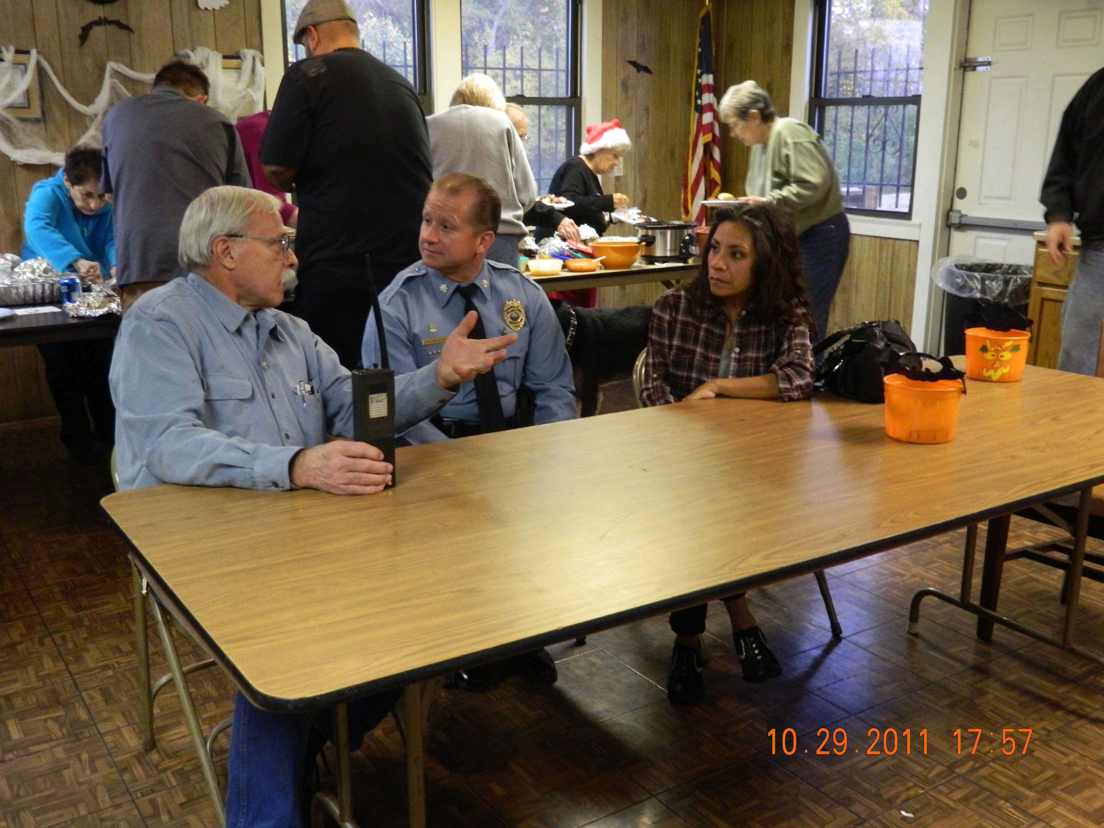  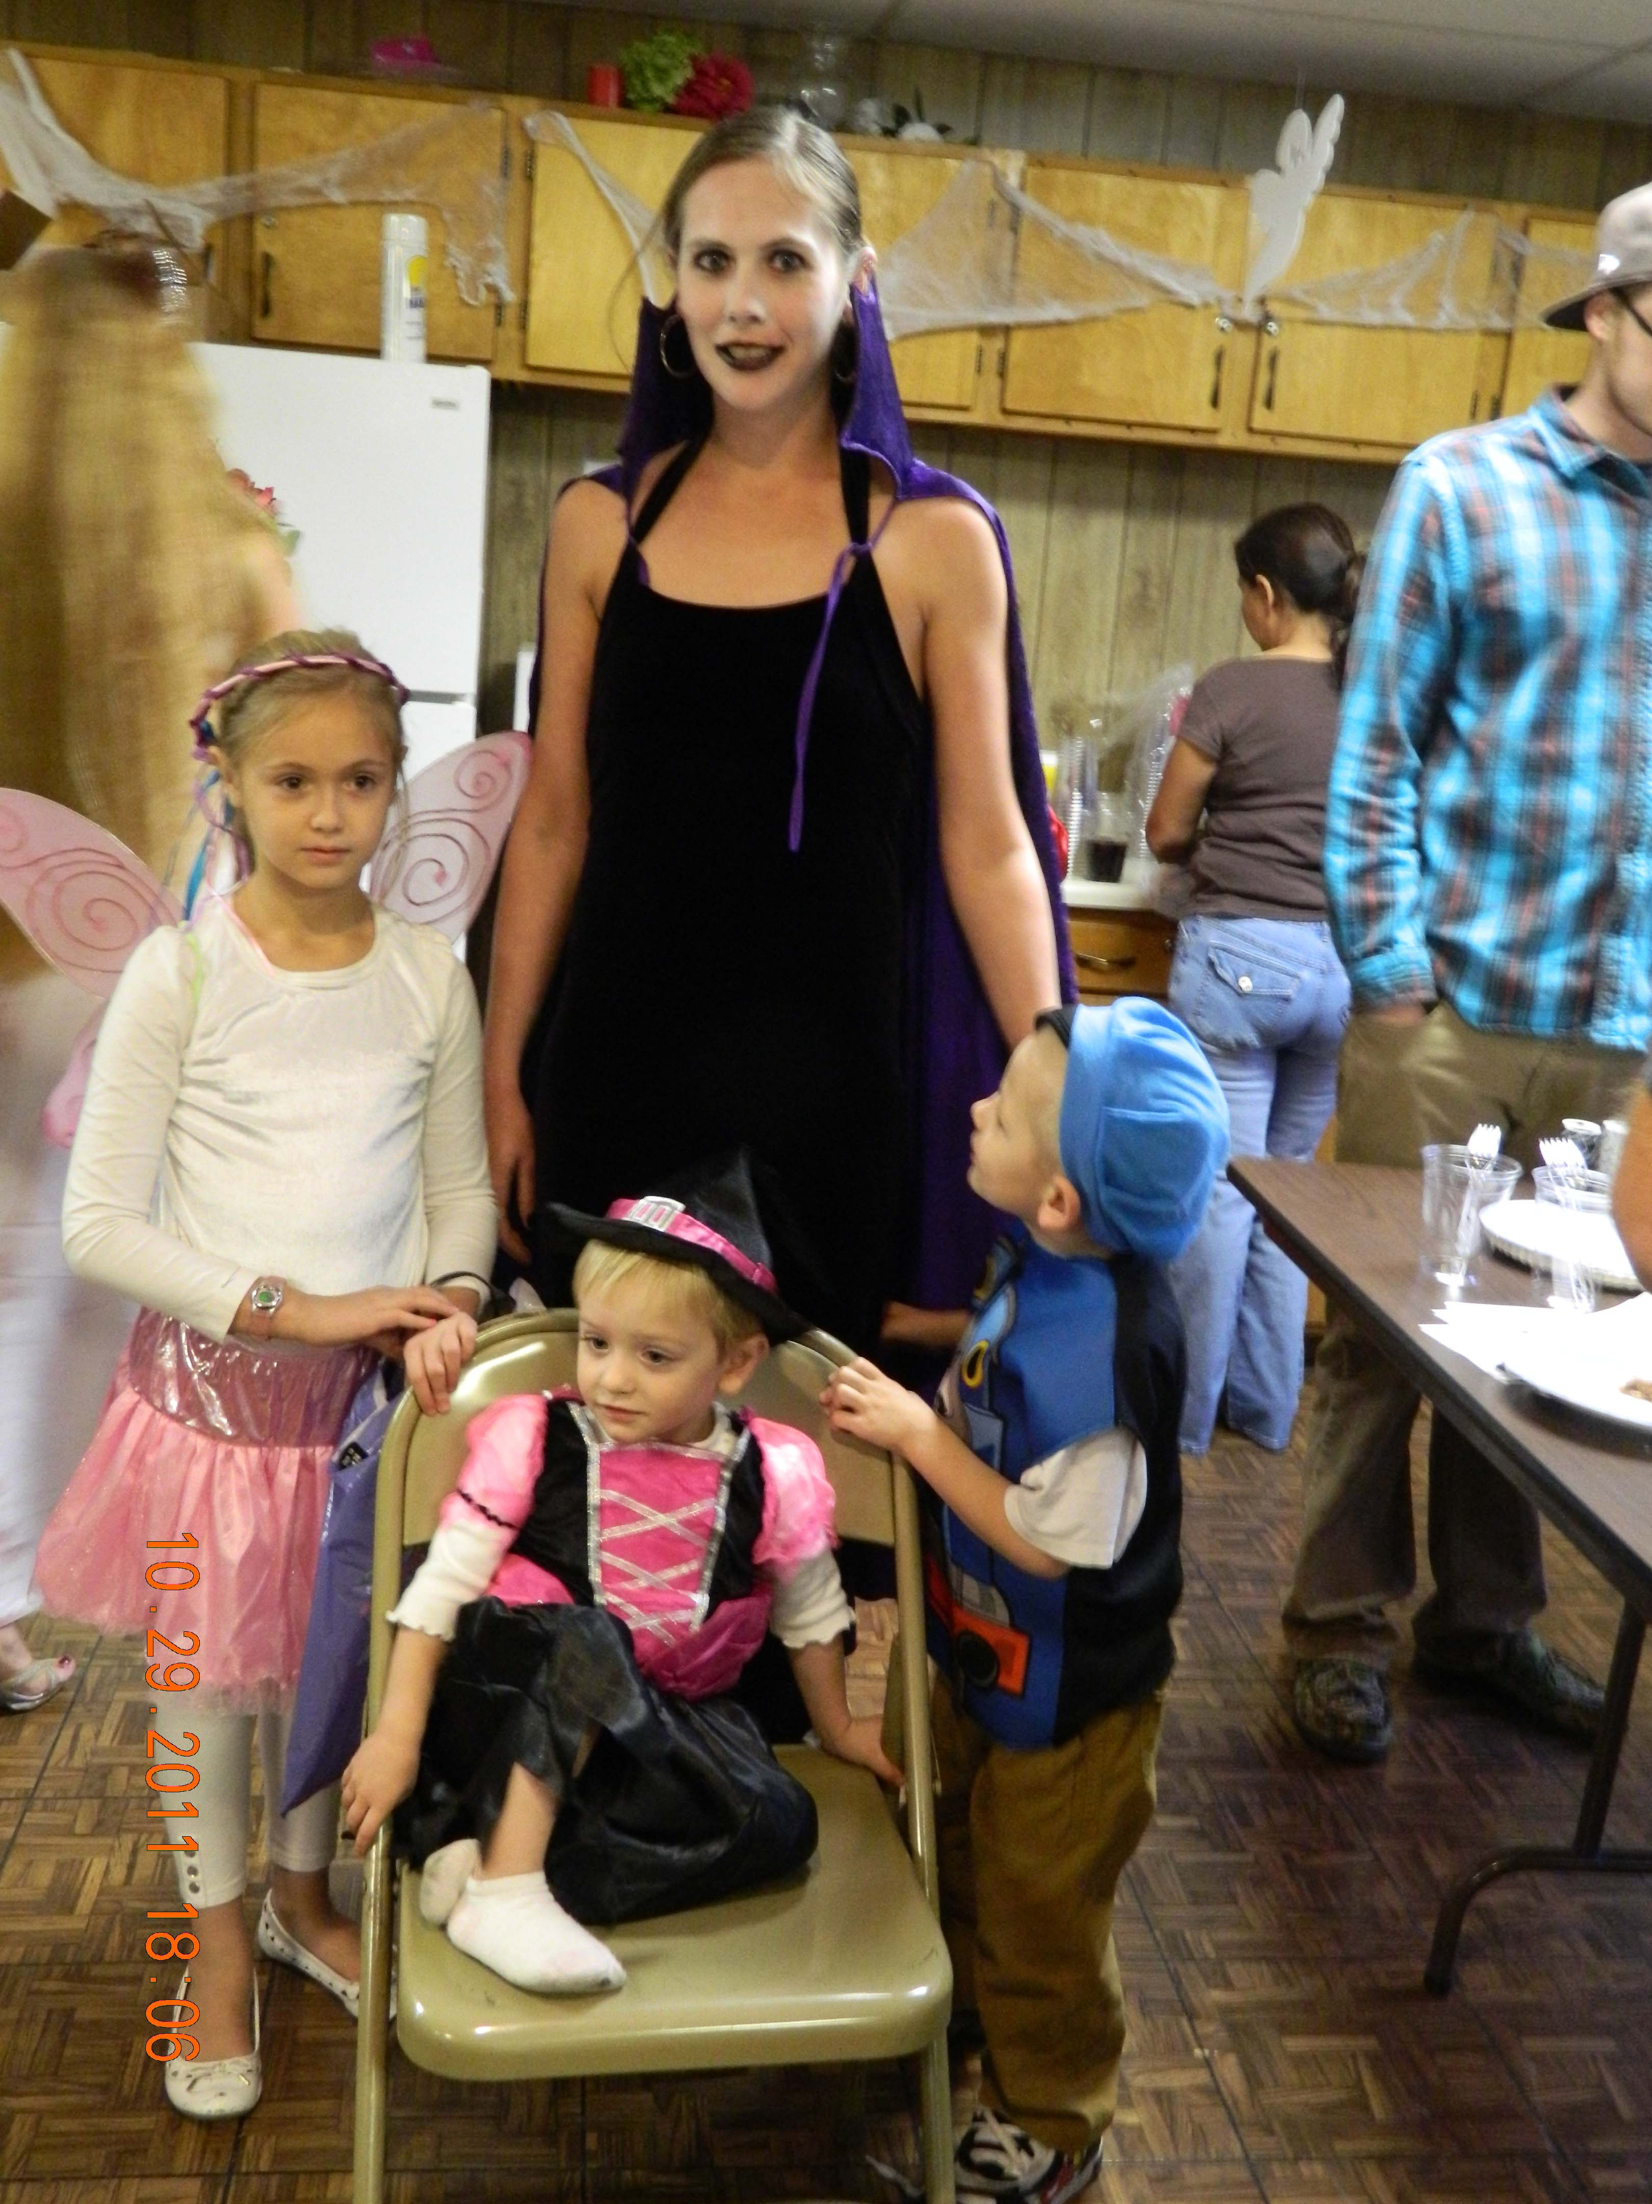 

 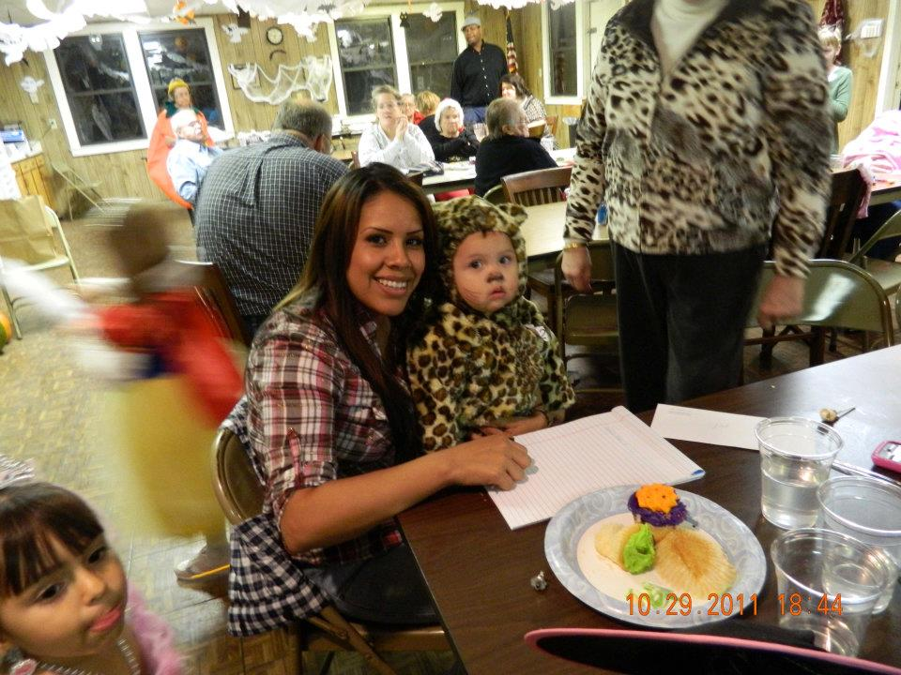 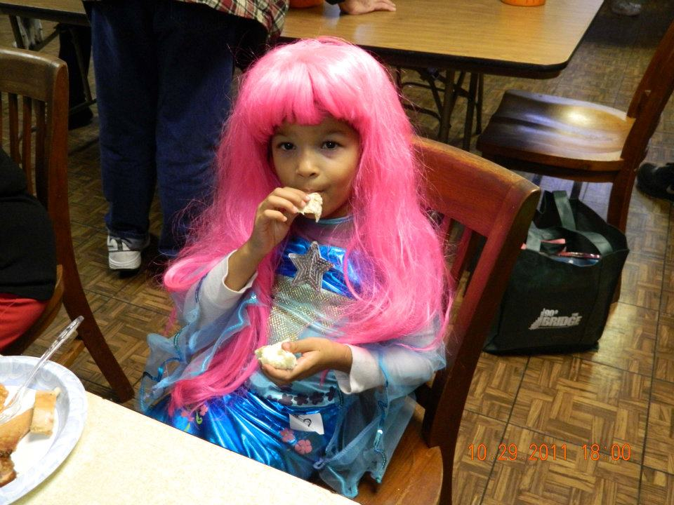



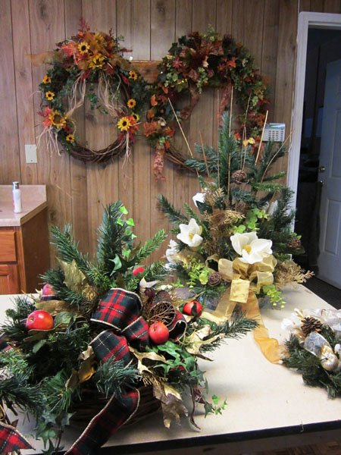 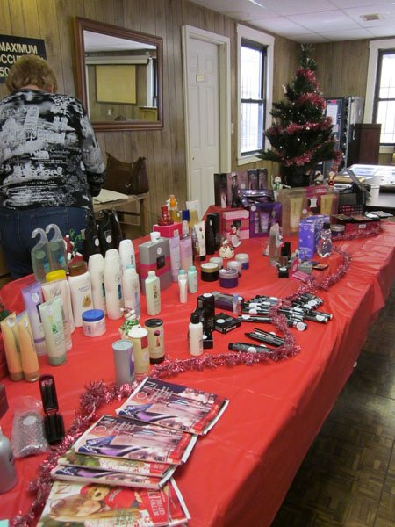 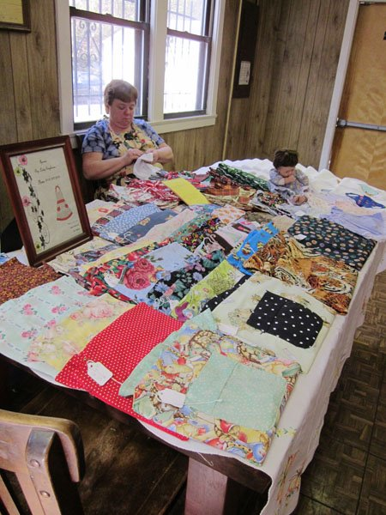 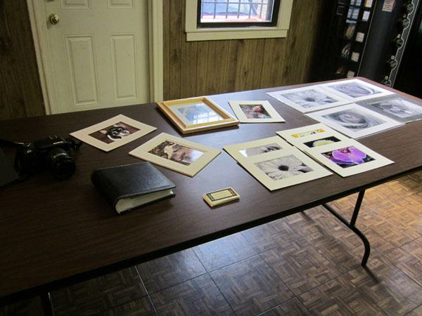

We hope to have another arts and crafts sale in March!

CRAFTS

ARTS

**MINUTES OF THE BOARD OF DIRECTORS**

**THE HOMES, INC.**

**November 21, 2011**

President Harold Watson called the regular monthly meeting of the Board of Directors of The Homes, Inc. to order at 6:00 p.m. on November 21, 2011.

Present were: Harold Watson, Charles Sawyer, Elaine Hines Jena Garr and Karen Anver, Board Members; Elizabeth Bothwell, Manager; Greg Goheen, Attorney; and Karen Brokesh, Transcriber.

Seventeen stockholders attended the meeting.

President Watson welcomed the stockholders to the meeting and announced that, as provided by the By-Laws of the corporation, only stockholders of record are entitled to attend the board meeting. President Watson also asked all stockholders in attendance to hold their questions and comments until after the finish of regular business at which time anyone who wishes to speak will be allowed to make a statement.

President Watson reminded the stockholders to state their name and address so that the minutes can accurately reflect all comments made during the open session. Stockholders were asked to hold their comments until executive session or to speak with the manager one-on-one if they did not want their comments reflected in open session.

Stockholders are reminded that if they have a problem with their unit, to please report it to the office during regular business hours.

It was announced that the work order report for October, 2011 has been posted.

Minutes of the regular meeting of October 17, 2011 and the October 17, 2011 Executive Session had previously been distributed to all board members. Elaine Hines moved to approve the minutes as written. Seconded by Charles Sawyer. Carried unanimously.

Treasurer Anver reported that the financial statements have been reviewed and were found to be in good order. The income statement and balance sheet were posted for the duration of the meeting. Charles Sawyer moved to accept the financial report as presented. Seconded by Jena Garr. Carried unanimously.

Stockholder change requests approved by the manager are as follows:

3151 N. 9th: Install cable television – Judy Reynolds. Work will be done by the cable service provider.

947 Viewcrest: Install satellite dish – Phillip Dale. Work will be done by Dish Network.

135 Viewcrest: Install Uverse – Noom Drowns and Honghern Ruangrong. Work will be done by AT&T.

The first stockholder change requests for board consideration was that of James Tavis, 936-942 Manorcrest, to install a natural gas generator at 936 Manorcrest to be used as an emergency power source. Work will be done by Jay’s Plumbing. Charles Sawyer moved to approve this change request. Seconded by Jena Garr. Carried unanimously.

The second stockholder change request for board consideration was from Shawn Sinn, 756 Manorcrest, to install a gas range. Work will be done by Jay’s Plumbing because there is currently no gas line. Charles Sawyer moved to approve this change request. Seconded by Elaine Hines. Carried unanimously

The third stockholder change request for board consideration was from Rebecca Westpfahl, 770 Manorcrest, to remove the closet wall in both bedrooms and remove the wall between the kitchen and laundry room. The wall to be removed is not a load bearing wall. This request was tabled until maintenance can inspect the area.

The last stockholder change request for board consideration was that of Velma Thompson and John Eberhardt, 742 Viewcrest, to remodel their bathroom by removing the bathtub and replacing it with a walk-in shower and install a new sink. Work will be done by Kevin Donavan. Charles Sawyer moved to approve this change request as long as the stockholders allow the plumbing to be inspected and replaced if necessary with the costs to be split with the corporation. Seconded by Jena Garr. Carried unanimously.

Secretary Hines read the stock transfer approvals as follows:

|  |  |  |
| --- | --- | --- |
| **ADDRESS** | **TRANSFER FROM** | **TRANSFER TO** |
| 82 Viewcrest | Arnoldo Moreno and Concepcion Moreno | Arnoldo Moreno, Concepcion Moreno and Deborah Moreno |
| 876 Manorcrest | Rebecca S. McGuirt | Michael Thomas Price and Robert Anver |
| 7 Viewcrest | Rachel Elaine Hines | Rachel Elaine Hines and Devra DeAnn Harrison |
| 3148 N. Allis | Judith A. Reynolds | Kayla M. Ross |
| 860 Manorcrest | Michael C. Herrera & Edna E. Herrera | Kimberly Sue Green & Dean Russell Bates |
| 971 Manorcrest | The Homes, Inc. | Clare Archer and Barbara Archer |
| 31 Summitcrest | William J. Conklin | The Homes, Inc. |
| 727 Manorcrest | Clare Archer and Barbara Archer | The Homes, Inc. |

After being informed that the stock transfers were in order, it was moved by Jena Garr and seconded by Karen Anver that the Corporation waive its option to purchase the first six shares of stock and approve transfer of same. Motion carried with Elaine Hines abstained. Jena Garr moved for the Corporation to exercise its option to purchase the last two shares of stock. Seconded by Karen Anver. Carried unanimously. The manager was reminded that all original signed stock certificates must be stored with the credit union if the stockholder has an outstanding loan.

*Announcements:*

The next Neighborhood Watch meeting will be held December 6th at 6:30 p.m. The police department has proposed changing the hours of the community police officers to 2:00 p.m. – 10:00 p.m. and most neighborhood watch groups are opposed because it will take the police officers off the streets during most of the day. Neighborhood Watch plans to attend an upcoming Unified Commissioners meeting to express their concerns.

The Financial Committee met this month and had no report.

There will be a Thanksgiving dinner for members of the community in the clubroom on November 24, 2011 from 1:00 p.m. – 6:00 p.m. Attendees are encouraged to bring a side dish or dessert.

The annual Christmas caroling party will be held in the clubroom on December 6, 2011 from 7:00-9:00 p.m.

The annual Halloween Party and BBQ Cook Off held October 29, 2011 was a big success.

Stockholders were reminded that they are responsible for keeping their steps and sidewalks clean of ice and snow this winter. Stockholders who are unable to do this themselves may contact the office for recommendations on persons to contact.

Epic Arts is offering clay art classes for children for $1.00.

Stockholders who have had branches and limbs come down into their yards during the recent wind storms may contact the office for assistance with removal.

Stockholders who see dogs running loose in the neighborhood should call Animal Control.

The speed limit throughout The Homes is 20 miles per hour. Please be alert and careful as you drive through the neighborhood and look out for children at bus stops.

Over 4,000 persons attended the September 24, 2011 Family Day and Carnival at the Kansas City Kansas Community College.

Volunteers are needed to wrap presents for the angel tree gifts again this year. Please contact the office if you are interested.

The plow and salt spreader are ready for the winter weather. Ice melt is available in the office for a small charge.

*Old Business to be Discussed:*

Fall inspections are almost complete. So far, twenty-one furnaces have had to be replaced at a cost of $1,200.00 per furnace.

The repairs caused by the fire at 727 Manorcrest are complete.

Manager reported that the Unified Government will submit the request for traffic calming devices to the street maintenance department next week. If the request is approved, an estimated time will be provided for installation.

*New Business to be Discussed:*

The Homes will be conducting an angel tree again this year to provide presents to needy children in the community. Letters have been sent out to vendors and local businesses requesting donations and $300.00 has been received to date.

Comments from Directors and Attorney:

None.

Comments from Stockholders:

Catherine Verderame, 788 Manorcrest, reported that a small dog has been getting into the trash near her unit.

Mary Jane Watson, 28 Viewcrest, commented on the number of security lights that are burned out in the neighborhood.

Sherry McCool, 12 Summitcrest, said she was thankful for living at The Homes and for its excellent staff.

Devra Harrison, 7 Viewcrest, said she was attending her first board meeting upon her return from military service.

Evelyn Dorman, 62 Viewcrest, thanked maintenance for helping her with the removal of yard waste recently.

Bob Anver, 108 Viewcrest, provided the board with photographs of Chuck O’Brien’s car being parked in the neighborhood and asked the board to take action to remove him from the property.

Lance Twyman, 3189 N. Allis, asked about why the speed bumps that used to be in the community were removed.

A raffle was held for a turkey dinner and a ham dinner which were donated by a stockholder. Rosetta Cantwell won the turkey dinner. Bob Whittington won the ham dinner.

No further business to come before the board the board adjourned into executive session.

______________________________

R. ELAINE HINES

SECRETARY

APPROVED:

____________________________

HAROLD WATSON

PRESIDENT

Transcribed by Karen Brokesh

Session $30 per setting

* 1-8x10 $20 per sheet
* 2-5x7 $15 per sheet
* 8-wallets $10 per sheet
* Special pricing for The Homes residents

**It’s time for Family, Holiday and Senior Student Pictures**

Contact Dee Dee at the office, 913-321-2471 to schedule a session.

  

**----------------------------------------------------------------------------**

Sample pictures Dee Dee has taken

Tide - Regular, Febreeze, and Rose Scent

Laundry Detergent, 5 gallons, $35

Downy - Blue Mix and Mountain Spring

Fabric Softner, 5 gallons, $35

Palmolive Dish Detergent, 5 gallons, $40

All detergent is concentrated and sold in 5 gallon containers.



Call Raul 913-961-4586

**----------------------------------------------------------------------**

**---------------------------------------------------------------------**

**EVENTS AT THE HOMES**

**Spiritual Study:** 2nd and 4th Thursdays of the month, 1-2pm at The Clubroom. All faiths welcome. Bring your bible. **Spiritual Study is cancelled the 4th Thursday of December**

**Christmas Caroling:** Tuesday, December 6, 6:30pm at The Clubroom. Refreshments will be served.

**Christmas With The Kids:**  Saturday, December 17, Noon – 2pm at The Clubroom. Again this year our vendors will sponsor the Angel Tree through monetary and gift donations. All children deserve a special Christmas. Parents can register their children at the office by December 9. Santa will be here to hand out the presents.

**EVENTS AROUND TOWN**

**New and Used Building Materials & Workshop:** Habitat for Humanity ReStore, 4701 Deramus Ave. K.C, MO or 303 W. 79th St. K.C., MO, 816-231-6889. Hours are Monday – Frid., 10am – 6pm (Donations/purchase pick-up until 5pm); Saturday, 9am – 4pm (Donations/purchase pick-up until 3pm); Closed Sundays.

**Medicare Savings Program Application Assistance** is offered by appointment, over the phone, or in your home. Senior Health Insurance Counseling for Kansas (SHICK) is a free program offering older Kansans an opportunity to talk with trained, community volunteers and get answers to questions about Medicare and other insurance issues. Please call the SHICK Hotline at 1-800-860-5260 to speak to a volunteer. If you are a resident of Wyandotte or Leavenworth County, you can reach a local volunteer at 913-573-8531.

**Quindaro Boulevard Family Health Care:** 530 Quindaro Boulevard, KCK 66101. Phone: (913) 722-3100. [www.swbfhc.org](http://www.swbfhc.org), **Se habla Español.** Your Health is important to us! Family Health Care provides primary health care for the entire family. Services include care for pregnant women, children and adults (including chronic diseases such as HIV, HepC and diabetes). Family Health Care is a non– profit safety net clinic with services provided on a sliding scale for those who do not have insurance. Our goal is to improve your family’s health by providing comprehensive health care services. **No patient is turned away for inability to pay.** Call (913) 722-3100 for an appointment. Monday - Friday Social and legal services from 12:00pm to 6:00pm Monday - Thursday The medical clinic is open 3:00pm to 6:00pm

**Workforce Partnership:** We are looking for youth 16 - 21 years old, In school junior and seniors and out of school youth. Ways We Can Help You: Prepare for the work environment (i.e. interview and resume workshops), Help with tools to obtain and hold employment, Assist with knowledge of what employers look for, Assesses personal career interest and goals, Assist with paying for post secondary education/ training, Assist in preparation for the ASVAB (for those interested in the military.) For more information call the Workforce Partnership at (913) 279-2600 or check them out at [www.kansasworks.com](http://www.kansasworks.com).

**11/19/11 to 1/29/12 - Christmas at the Strawberry Hill Museum**

720 North 4th Street, Kansas City, KS 66101, 913-371-3264  
The museum will open its doors to the Christmas season on November 19, 2011, welcoming visitors to over 30 rooms uniquely decorated as well as 32+ donated nativity sets on display in the chapel. Featured in the ethnic rooms are traditional decorations from that particular culture where volunteers from each nationality work on these displays. The Christmas Exhibit will run from November 19, 2011 to January 29, 2012.

**11/19/11 to 12/26/11 - A Christmas Carol - A Special Event**

[Kansas City Repertory Theatre](http://www.visitkansascityks.com/component/mtree/arts/kansas-city-repertory-theatre.html), 4949 Cherry Street, Kansas City , KS 64110, 816-235-2700  
In honor of last year’s 30th anniversary of A Christmas Carol, our venerable holiday production received a “makeover.” While staying true to the original Rep show we all loved, the set was rebuilt to include a revolving stage and other theatre magic that surprised and delighted audiences. For more than three decades, the Rep’s enchanting holiday show has captured the true meaning of Christmas for many Kansas City families, who year after year are inspired by its strong family values and message of hope and redemption. Make the Rep’s A Christmas Carol a part of your holiday celebration this year.

**11/19/11 5:00pm to 1/2/12 10:00pm - A Legendary Light Show**

[Legends Outlets Kansas City](http://www.visitkansascityks.com/component/mtree/shopping/legends-outlets.html), 1843 Village West Parkway, Kansas City , KS 66111, 913-788-3700  
Every 15 minutes, The Legends will come alive with dancing lights synchronized to concert-quality, holiday music, providing guests an experience unlike anything they have seen before. This dazzling spectacle is the region's first display of animated lights synchronized to music. The majestic, 45-foot, holiday tree will continue to stand in the center of the Civic Courtyard Fountain, which is the focal point of the shopping center. The musical show in the center courtyard will take place at the top and bottom of every hour. A second show will be featured at a quarter after and a quarter till the hour at the new holiday tree and display located near Helzberg Diamonds

**12/3/11 - Breakfast with Santa at the** [**T-Rex Cafe**](http://www.visitkansascityks.com/component/mtree/dining/t-rex-cafe.html)   
1847 Village West Parkway, Kansas City , KS 66111, 913-334-8888  
December 3, 4, 10, 11, 17 & 18. Enjoy Breakfast with Santa at the T-Ref Cafe!

Breakfast Buffet, Caroling, Free Goodies for the kids, Raffles with cool prizes and of course, Santa Claus!

 Call to make your reservations 913-334-8888.

**12/10/11 10:00am to 8:00pm - Holiday Homes Tours**

[Grinter Place Historic Site](http://www.visitkansascityks.com/component/mtree/meeting-facilities/grinter-place-historic-site.html), 1420 South 78th Street, Kansas City , KS, 913-334-2500

Details: Tour the house built in 1857, enjoy holiday music by various high school groups, watch wood-stove cooking demonstrations and sample treats, visit Santa. 1420 S. 78th St. Dec. 10, 10 a.m.-4 p.m.

Tickets: $3 for adults; $1 for students; 5 and under free

**12/11/11 1:00pm to 5:00pm - Westheight Holiday Homes Tour**

Off North 18th St., west on Washington Blvd., Kansas City , KS, 913-371-3495  
Seven homes in Westheight Manor will be dressed up for the holidays and ready for company! Visit a charming 1930s English Tudor home, a Spanish Colonial Revival home, a unique Japanese Airplane Bungalow and an English Garden residential court! Other styles in the area include Arts & Crafts, Italian Renaissance and Spanish Eclectic. In addition, the 152-year-old St. Paul’s Episcopal Church, at 1300 North 18th Street, will be open for touring. Tickets may be purchased on the day of the tour at the church. Visitors will also see a demonstration of ice carving by a professional ice sculptor.

Westheight Manor is listed as historically significant in the National Register of Historic Places and the Register of Historic Kansas Places.

**In Rememberance of all the family and friends of the Homes that have passed away this year.**

*Your smile alone warmed hearts. Your laugh was like music to hear. I would give absolutely anything to have you well and standing near. Not a second passes when you are not on our minds. Your love we will never forget and the hurt will ease in time. To have, to love, and then to part, is the greatest sorrow of one’s heart. So when you look up, perhaps they are not stars in the sky, but rather openings where our loved ones shine down to let us know they are happy.*

*Curtis King Ed Scholten Floyd Culp*

*James Neill Gregory Quinn Elle Greco*

*Wilma Brown Mary Ontiveros-Snowman “Country” Herman Wallace*

*George (Office dog)*

**

*If we omitted a loved one know that we all can share in this remembrance.*

C:\Users\The Homes\AppData\Local\Microsoft\Windows\Temporary Internet Files\Content.IE5\DRN7Q8BA\MCj04420360000[1].wmf HELPFUL HINTS ABOUT LIVING IN THE HOMES

**BURN PILE AND DUMPSTER.** Contact the office before dumping items in the burn pile or the dumpster located at the office. The burn pile is for yard waste (tree limbs, brush, and grass) only. DO NOT PLACE BUILDING MATERIALS IN THE BURN PILE.

**TOD.** The office has an official TOD (Transfer on Death) form. In the event of your death, who will your home go to. If you do not have a will or a TOD, the state will control who your home goes to. Please secure your future and request/complete this form.

**LITTERING.** Think twice about throwing your trash out your car window or into someone's yard. First, it's rude and selfish. Someone will have to pick it up and most of the time it is the maintenance staff. This takes time and money away from other residents needs. Second, it is against the law. Littering is a Class C violation that is punishable by a fine up to a $500.00. If you are witnessed littering the police will be called and you will be charged, by The Homes, for the time it takes to pick it up and dispose of it.

**TOYS & BIKES:** Please do not leave toys & bikes in the parks. They create a mowing hazard and a opportunity for thieves. If you have lost a toy or bike in a park, check the office to see if it was picked up.

**CARBON MONOXIDE DETECTORS:** Carbon monoxide or CO is found in combustion fumes that are produced by gas stoves and heating systems. CO from these sources can build up in enclosed or semi-enclosed spaces. People and animals in these spaces can be poisoned by breathing it. The Homes offers carbon monoxide detectors for $25 installed.

**KEEP FURNANCE AND WATER HEATER AREAS CLEAN.** Having too many clothes, boxes, or general clutter in your utility area can be a fire hazard. Please keep yourself and your neighbors safe and keep your utility areas clean.

**ONLY FLUSH TOILET PAPER.** The pipes in our homes are over 60 years old. They do not have the capacity to wash away any other material. Do not flush baby wipes, feminine hygiene products, diapers, paper towels, Q tips, etc. If maintenance finds these items consistently causing a back up in your pipes you may be charged for the repair.

**PARKING:** The Homes does not have assigned parking. Please be considerate of your neighbors and their parking needs. Try not to park in a spot that is normally used by your neighbor. If you have guest, have them park in the overflow lots.

**YARDS & PORCHES:** Please take the time to clean up/organize your yard and porch. The size of our porches do not allow for you to keep many items on them before they start to look cluttered and messy. If you do not have a shed an affordable idea to store your items in are: deck and patio boxes. They range in cost from $30 to $100 and can be purchased on-line or at your local discount store. Items that should not be on your porch: appliances, boxes, buckets, mops, paint containers or any other "non outdoor" items. The office offers free paint for the porches.

**STICKS AND LIMBS:** Place sticks/limbs in 4 foot bundles to the curbside for pickup by maintenance.

**All Welcome: The Bruised, Battered and Cast Aside**

The Humane Society of Greater Kansas City has been a safe haven for animals needing help since 1912. Like other shelters across the nation we take in homeless animals and provide a safe place for them to wait until they are reunited with their owners or adopted into a new home. What makes the Humane Society of Greater Kansas City different from most shelters across the nation is the philosophy and dedication to do whatever it takes to save every pet that comes into our care – no matter the animal’s health, situation or the cost involved.

Our no-kill philosophy extends to help pets in need -- not just the healthy and easy to place ones. We believe all animals deserve a chance and even if they’re not perfect there’s someone out there who will think they are the perfect pet for them. We specifically take in pets that wouldn’t have a chance in many other places, and while in our care if we discover a health or behavior problem we don’t give up on them either

**How Can You Adopt a Shelter Pet?**

To adopt any of the sweet pets at The Humane Society of Greater Kansas City, download our one-page adoption application form from hsgkc.org, complete the form and email it to **Karen@hsgkc.org**, or fax it to 913.596.2483. If you have specific adoption questions, not answered by our website, please call 913.596.1000. Our adoption process is a matching process of matching you with the right pet and vice versa. (No same day adoptions.) Most of our dogs do require a fenced yard.

**Shelter Hours**

Mon. – Fri. Adoptions 9 am – 5 pm **General Info**………………… 913.596.1000

Saturday Adoptions 9 am – 4 pm **To See the Pets**………………… hsgkc.org

Mon. – Fri. Clinic 9:30 am – 4 pm **Volunteer Info**………913.596.1000 ext. 122

**To Make a Gift**………913.596.1000 ext. 114

**Mandatory Spay/Neuter: Something to Ponder**

Like many issues in animal welfare, mandatory spay/neuter laws

have their supporters and detractors. One of the key successes of our Ray of Hope project has been the enforcement of mandatory spay/neuter in Wyandotte County. The results are amazing. In addition to maintaining a no kill status for the county (less than 1%), we have witnessed a 56% reduction of animals going into the KCK Animal Control shelter in the last three years! Make no mistake, this is not directly a result of spay/neuter itself (that will come later), rather it’s the enforcement. Early on we talked with the municipal circuit court, in which pet owners receiving citations would be given 30 days to get into compliance with all of the local ordinances for pets. It turns out that it is cheaper to get into compliance, than to be assessed the full fee by the court and have the animal removed from the home. A win/win for both animal and pet owner!

Targeted spay/neuter grants have made this even more successful. Dividends from spay/ neuter are being felt across the metro area as intake in most shelters have been declining for the last several years even as the number of spay/neuter surgeries are going up! We know adoption numbers are generally flat in the long term. If the metro area can further reduce the number of animals needing to go into shelters to the point of matching that adoption number, we would see the whole KC metro area become a no kill community.

Shirley Elmore, a resident at The Homes, gladly volunteers to take any resident’s pet to receive shots and be spayed or neutered at the Humane Society of Kansas City, Kansas. Shirley can be reached at 913-621-4628. Shirley’s endeavors to help animals within are community are time consuming and costly. A “Save the Animals” savings account has been created at the Quindaro Homes Federal Credit Union. All donations are appreciated and go towards the betterment of the animals. You can drop off donations at the office or directly mail a donation to the credit union (QHFCU, 660 Manorcrest Dr., Kansas City, KS 66101). Please note on the donation that it is for the “Save the Animals” fund.

**AUTO**

PUBLIC SERVICE ANNOUNCEMENTS

|  |  |  |
| --- | --- | --- |
| Jose’s Auto Service | 1413 N. 18th KC Ks | 913.371.9101 |

**CHURCH**

|  |  |  |
| --- | --- | --- |
| Bridge of Hope Community Church | 1925 N. 11th KC Ks | 913.499.6741 |

**COMPUTER**

|  |  |  |
| --- | --- | --- |
| Heartland On-Site Services | Joe Dix | 913.735.7121 |

**FURNANCE / AIR CONDITIONING**

|  |  |  |
| --- | --- | --- |
| Clair Heating & Cooling | Jon Clair | 913.334.4020 |
| RBG Heating & Cooling |  | 913.952.5122 / English  913.562.4479 / Spanish |
| Schuler Heating & Cooling |  | 913.262.2969 |
| Smitty’s Heating & Cooling | Joe Smith | 913.299.1488 |

**HOME REPAIR**

|  |  |  |
| --- | --- | --- |
| Air Duct Cleaning/Carpet Cleaning | Rosario Ortiz | 816-215-5114 |
| Handyman Pros &  Real Deal Pressure Washing | Brandon Deal | 913.707.2669 |
| L. Donnell & Sons Construction | General Const & Elect. | 816.820.8227 |
| Reliable Flooring | Shawn Walters | 913.944.1970 |
| Wallpaper Hanger/Painter | Annamaria | 816.810.8872 |

**LAWN CARE**

|  |  |  |
| --- | --- | --- |
| Todd Bothwell |  | 816.517.6639 |
| Leaf/ Snow Removal  Ice Melt Application | Matt Eklund | 913.526.2974 |
| J D Jackson |  | 816.803.9914 |
| Rolling Reel Grass Cutting | J. Hall | 913.233.2541 |
| Yard Work | Annamaria | 816.810.8872 |

**NOTARY / TAX SERVICE**

|  |  |  |
| --- | --- | --- |
| Becky, Tax Representative |  | 913.232.7339/816.516.1959 |
| Open Door Mobile Notary | Mary Jane Watson | 913.281.4405 |

**PERSONAL**

|  |  |  |
| --- | --- | --- |
| Artistry Cosmetics | Mary Jane Watson | 913.281.4405 |
| Avon | Karen Anver | 913.342.2660 |
| Angels of Grace Child Center  (2 ½ weeks – 12 yrs old) | 1220 Troup Ave Ste B | 913.233.2944 |
| Custom Made to Order Jewelry & Watch Repair | Tammy Eklund | 913.342.2326 |
| Guitar Lessons | Shawn Reitmayer | 816.462.7177 |
| Hair Salon | Niki | 913.710.6216 |
| Housecleaning | Angelica | 816.756.7418 |
| Housecleaning/Errands | Jennifer | 913.226.1698 |
| House-sitting/Pet & Plant Care | J. Hall | 913.233.2541 |
| Housecleaning/Babysitter (24hr)/Dog Walker | Annamaria | 816.810.8872 |
| Sell It on EBay | Bob Anver | 913.342.2660 |
| Tina’s Alteration & Repair |  | 913.633.1495 |

**PET SUPPLIES**

|  |  |  |
| --- | --- | --- |
| Dresslers Dog Supplies | 1708 Steele Rd KC Ks | 913.722.2430 |

**PHOTOGRAPHY**

|  |  |  |
| --- | --- | --- |
| Freeze Frame Photography | Dee Dee Johnson | 816.716.8865 |

**RECYCLING**

|  |  |  |
| --- | --- | --- |
| C & E Recycling | Chris | 913.904.8501 |
|  | Eric | 913.907.6764 |

**FOR SALE**

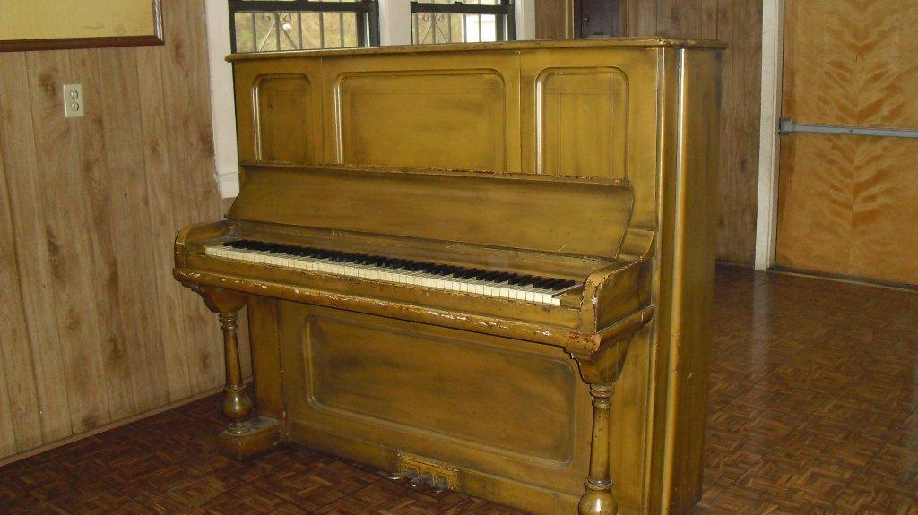 Heinz Chicago Piano-Free

* Kohler Pedestal Sink, $150, Call Mark, 913-281-1868
* 4 grave plots next to office at entrance of Chapel Hill Memorial Gardens. Plots sell for $2,000 each, asking $700 each. Call Jimmie, 913-271-3228
* Kenmore Heavy Duty Gas Dryer, $50. Call Annamaria, 816-810-8872
* Maytag Washer & Electric Dryer, $100. Call Martha, 913-281-4298

**\*\*NOTIFY THE OFFICE IF YOUR ITEM SELLS SO IT CAN BE REMOVED FROM THE FOR SALE LISTING\*\***

 Happy Birthday to those residents that celebrate their birthday in December!

TO MAKE AN ANNOUNCEMENT SUCH AS A BIRTHDAY, WEDDING OR DEATH, PLEASE CALL THE OFFICE

**In Memory of:**

Herman “Country” Wallace passed away November 12. Our thoughts are with the family.

|  |  |  |  |  |
| --- | --- | --- | --- | --- |
| One Bedroom  THE HOMES  UNITS FOR SALE | Amenities | Owner | Phone | Price |
| 900 Manorcrest |  | Deal | 913.707.2669 | $ 5,500 |
| 31 Summitcrest |  | The Homes | 913.321.2471 | $ 6,200 |
| 3132 N Allis (Appt Only) | Appliances  s/h will pay 3 months of maintenance fee | Marquis/  HofMiller | 816.518.1165 | $ 8,775 |
| Two Bedroom Up |  | Owner | Phone | Price |
| 787 Manorcrest | C/A | Green | 913.321.6947 | $ 7,500 |
| 873 Manorcrest |  | The Homes | 913.653.1313 | $ 5,000 |
| 67 Viewcrest | Appliances | Lin | 913.548.6699 | $ 5,000 |
| 113 Viewcrest |  | Melendez | 913.233.1067 | $12,000 |
| 3183 N 9 (Appt Only) | C/A | Byers | 913.371.1226 | $ 9,500 Make Offer |
| Two Bedroom Down |  | Owner | Phone | Price |
| 727 Manorcrest | C/A, Shed | The Homes | 913.321.2471 | $ 8,500 |
| 741 Manorcrest |  | The Homes | 913.321.2471 | $ 7,000 |
| 954 Manorcrest | C/A, Basement | Ramos | 913.621.4532 | $13,000 |
| 959 Manorcrest | C/A | Schlaman | 785.393.0520 | $ 8,500 |
| 826 Roswell |  | Patlan | 913.963.4095 | $ 9,500 |
| 841 Roswell |  | Gregg | 913.371.5673 | $10,233 |
| 12 Viewcrest | C/A, Stove, Fridge, Shed | Gaeta | 913.235.7573 | $ 8,000 |
| 69 Viewcrest | Appliances, C/A | Avila | 913.645.8603 | $ 9,350 |
| 80 Viewcrest | C/A, Deck, Shed | Vandaveer | 816.721.3759 | $14,000 |
| 115 Viewcrest | Stove, No C/A | Rivas | 913.371.3001 | $ 9,000 OBO |
| 130 Viewcrest | C/A, Deck, Patio, Shed | Rivera | 913.522.9147 | $ 9,500 |
| 131 Viewcrest | No C/A | Acosta | 913.271.3744 | $10,000 |
| 5 Craigcrest | C/A, Stove, Fridge, W/D | Prince | 913.999.1599 | $12,000 |
| 3175 N 9 | Stove, Fridge | Prince | 913.400.1133 | $12,500 |
| 3000 N Allis |  | Walther | 856.278.1040 | $ 10,000 |
| 3149 N Allis |  | Hernandez | 913.563.2635 | $ 13,500 |
| Three Bedroom |  | Owner | Phone | Price |
| 948 Manorcrest (Appt Only) | Shed | Ontiveros | 816.585.4469 | $16,000 |
| 21 Viewcrest | C/A,Stove, Fridge, W/D, D/W | Steffen | 816.728.1508 | $ 8,000 |
| 133 Viewcrest | C/A,Stove, Fridge, W/D, D/W | The Homes | 913.321.2471 | BID |
| 135 Viewcrest | C/A, Stove, Deck | Drowns | 816.739.5626 | $11,500 OBO |
| 138 Viewcrest | Stove, D/W, No C/A | Magill | 913.530.7300 | $ 8,000 |
| 139 Viewcrest | Appliances | Dulac | 913.205.4000 | $10,000 |
| Double Unit |  | Owner | Phone | Price |
| 6/8 Summitcrest | C/A, Stove, Fridge, W/D, Driveway | Jones | 913.602.5361 | $16,000 |
| 23/25 Summitcrest | Appliances | Forcier | 816.679.0801 | $12,500 |
| 39/41 Summitcrest | Stove, Fridge | Lopez | 913.952.5386 | $25,000 OBO |
| 84/86 Viewcrest (Appt) | C/A, Shed | Eberhardt | 913.281.5847 | $22,000 |

|  |  |
| --- | --- |
| Quindaro Homes Federal Credit Union  As of October 31, 2011 | NEEDED |
| Assets: |  |
| LOANS | 576,224.65 |
| ALLOWANCE FOR LOAN LOSSES | - 12,165.53 |
| SECURITY BANK | 182,935.85 |
| CHANGE FUND | 200.00 |
| COMMUNITY AMERICA CU – SAVINGS | 62.09 |
| COMMUNITY AMERICA CU – CD | 104,600.33 |
| BANK MIDWEST | 53,468.10 |
| KCCU MEMBERSHIP SHARES | 11,428.85 |
| KCCU CASH MANAGEMENT | 1,423.79 |
| CREDIT UNION 1 SAVINGS | 26.26 |
| INDUSTRIAL STATE BANK | 84,364.90 |
| INTERSTATE FEDERAL SAVINGS & LOAN | 1,548.06 |
| INTERSTATE FEDERAL SAVINGS & LOAN | 100,000.00 |
| M & I BANK | 100,000.00 |
| COMMERICAL STATE BANK OF BONNER SPRINGS | 100,000.00 |
| PREPAID INSURANCE | 3,431.47 |
| NCUSIF | 11,253.82 |
|  |  |
| **TOTAL ASSETS** | **1,318,802.64** |
|  |  |
| Liabilities: |  |
| ACCOUNTS PAYABLE | 0.00 |
| AUDIT FEE - PAYABLE | 0.00 |
| NCUSIF PREMIUM PAYABLE | 444.00 |
| FEDERAL & KANSAS TAXES DUE | 55.00 |
| SHARED DIVIDENDS PAYABLE | 631.07 |
| MEMBER SHARES | 1,070,531.50 |
| REGULAR RESERVES | 31,510.21 |
| RESERVE FOR CONTINGENCIES | 26,500.00 |
| UNDIVIDED EARNINGS | 188,772.21 |
| NET INCOME | 358.65 |
|  |  |
| **TOTAL LIABILITIES** | **1,318,802.64** |

ATTENTION: The Board of Directors has voted to send only the Annual statement this year which will be mailed December 31, 2011. If you desire a statement as of June 30, 2011, please call the Credit Union Office at 913-342-3421.

|  |  |  |  |  |  |  |
| --- | --- | --- | --- | --- | --- | --- |
| December 2011 | | | | | | |
| Sunday | Monday | Tuesday | Wednesday | Thursday  1 | Friday  2 | Saturday  3 |
| 4 | 5 | 6  **NEIGHBORHOOD**  **WATCH –CHRISTMAS CAROLING**  **Clubroom**  **6:30PM** | 7 | 8  **SPIRITUAL STUDY, Clubroom**  **1-2 PM** | 9 | 10 |
| 11 | 12 | 13 | 14 | 15 | 16 | 17  **CHRISTMAS WITH THE KIDS**  **Clubroom**  **Noon-2 PM** |
| 18 | 19  **THE HOMES BOARD MEETING**  **6 PM** | 20 | 21  **CREDIT UNION BOARD MEETING**  **4:30 PM** | 22 | 23 | 24 |
| 25  **MERRY**  **CHRISTMAS** | 26  **CHRISTMAS**  **THE HOMES AND CREDIT UNION OFFICES CLOSED** | 27 | 28 | 29 | 30 | 31  **NEW YEAR’S EVE** |

NEWSLETTER INFORMATION: This newsletter is intended to inform and notify in an unbiased form. It is published in cooperation with The Homes, Inc., The Quindaro Homes Neighborhood Watch, The Quindaro Homes Federal Credit Union, and the stockholders of The Homes, Inc. No discrimination against any person or group is intended or tolerated. If a stockholder would like to submit material for the Newsletter, please submit to the office in writing no later than the 20th of the month. **Newsletter Editors, Elizabeth Bothwell and Debbie Walters**

**DECEMBER TRIVIA & FUN**

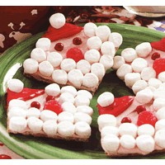

[Santa Crackers](http://www.freekidscrafts.com/santa_crackers-e144.html)

Kids will enjoy making these jolly Santa crackers as a treat for Santa himself or for all the [hungry](http://www.freekidscrafts.com/santa_crackers-e144.html) little elves at your holiday table.

**Supplies**

Graham crackers   
Pillsbury canned vanilla frosting   
Red and rose [food](http://www.freekidscrafts.com/santa_crackers-e144.html) coloring (we used paste)   
Mini Red Hot candies (eyes)   
Red gumdrop (nose)   
Mini marshmallows

**Instructions**

Frost the entire cookie with "pink" (use rose colorant) frosting. Snip off the corner of a zipper lock bag and put a dab of "red" frosting on one corner of graham cracker, then using a small butter knife spread the frosting to make the hat and while frosting is still moist, add one mini marshmallow for tassel. Add mini marshmallows for the beard, red-hot candies for the eyes and red gumdrop for the nose. If frosting dries out before you can add the accessories, just gently pat with a wet finger.

[Flower Pot Pens](http://www.freekidscrafts.com/flower_pot_pens-e31.html)

This attractive display of flower topped pens makes a practical and beautiful gift for young crafters to make for their favorite teacher. The pens won't disappear because everyone will know where they belong.

**Supplies**

Your choice of artificial flowers (at least 6 stems)

Small clay [flower pot](http://www.freekidscrafts.com/flower_pot_pens-e31.html) (4-inch diameter top)   
1 Roll of green florists tape   
Package of pens (one pen for each flower stem)   
2 Cups assorted dried [beans](http://www.freekidscrafts.com/flower_pot_pens-e31.html), pebbles or aquarium rocks   
Craft ribbon   
Cardboard   
[Craft](http://www.freekidscrafts.com/flower_pot_pens-e31.html) glue

Glue gun

**Instructions**

Cut a circle of cardboard to fit snugly in the bottom of the flower pot to cover the hole then glue in place. Fill the pot about half way full with beans or pebbles.

Use florists tape to tape the pen (with the point facing away from the flower petal) to the flower stem making sure the pen cap will fit after taping.

Wrap craft ribbon around the flower pot and [secure](http://www.freekidscrafts.com/flower_pot_pens-e31.html) using glue gun.

Arrange flower pens in pot.